How to configure GitHub webhook to trigger a job ?

Open repository you want to configure and select settings:

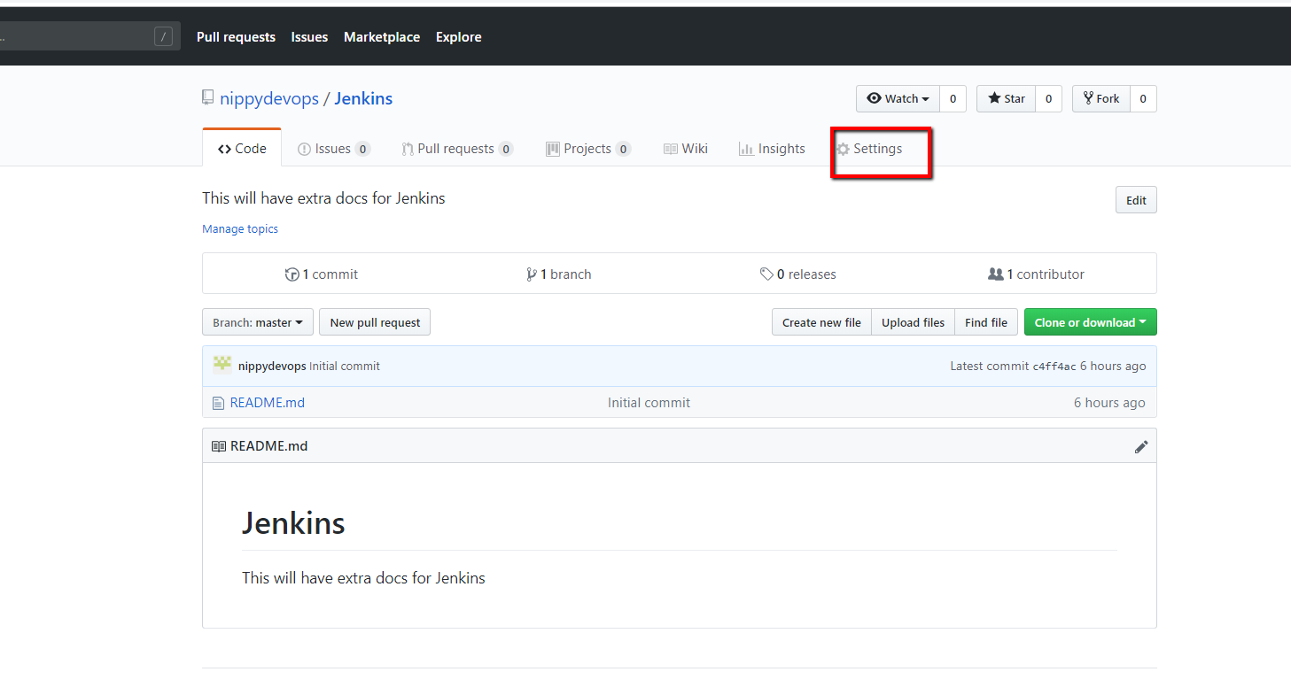

1. Navigate to the "Settings" tab.
2. Select the "Webhooks" option on the left menu

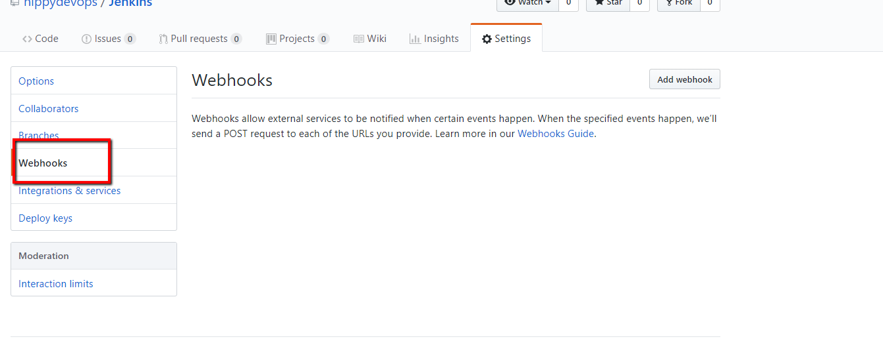

1. Click "Add Webhook"

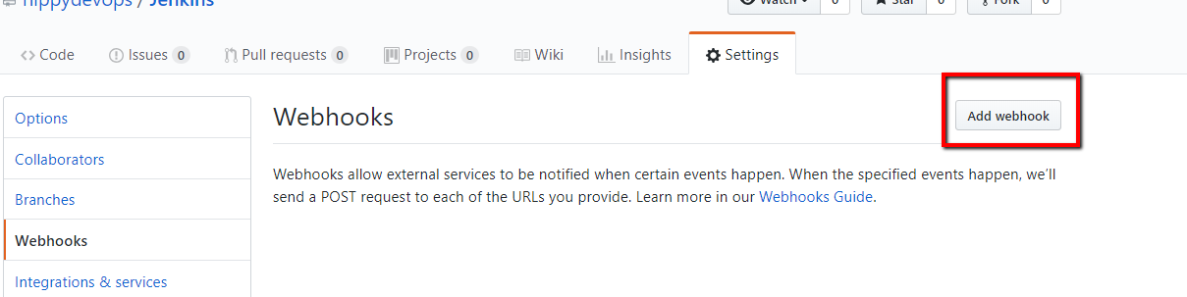

1. For "Payload URL":
   * Use the address for the Jenkins server instance
   * Add /github-webhook/ to the end of it.
   * Make sure to include the last /!
     + example: <http://myjenkins.com/github-webhook/>

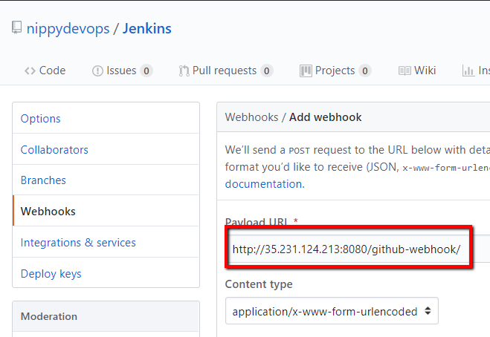

1. Select "application/json" as the encoding type
2. Leave "Secret" blank (unless a secret has been created and configured in the Jenkins "Configure System -> GitHub plugin" section)
3. Select "Let me select individual events"
   * Enable PUSH event
   * Enable Pull Request event

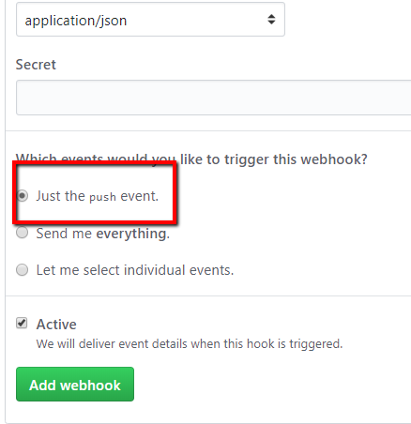

1. Make sure "Active" is checked

Now configure Job to be executed remotely:

